Date September 2019
Subject 21 as the minimum age for tobacco and e-cigarette sales

Policy Recommendation
The Canadian Cancer Society recommends that the Government of Nova Scotia amend the Tobacco Access Act to prohibit the sale of all tobacco and e-cigarette products to individuals under the age of 21.
Background
Increasing the minimum legal age for access to tobacco and e-cigarette products to 21 would reduce smoking initiation, reduce the prevalence of smoking, improve health outcomes, and save lives. Tobacco 21 laws are effective and enjoy high levels of public support.
In the U.S., eighteen states – Arkansas, California, Connecticut, Delaware, Hawaii, Illinois, Maine, Maryland, Massachusetts, New Jersey, New York, Ohio, Oregon, Texas, Utah, Vermont, Virginia and Washington – have raised the tobacco age to 21, along with Washington, D.C. and at least 480 localities.
In all 18 US states with age 21 for tobacco, the law also applies to establish age 21 for e-cigarettes. The dramatic increase in youth use of e-cigarettes in the US, described by the FDA and by the US Surgeon General as an epidemic, is driving more states to adopt age 21 for both tobacco and e-cigarettes.

In Canada, there has been a similarly dramatic increase in youth use of e-cigarettes, prompting the need to adopt age 21 laws as soon as possible. Here is a summary of trends published by Health Canada on Feb. 16, 2019:

The Canadian Student Tobacco, Alcohol and Drugs Survey (CSTADS) results from 2016–2017 indicate that 15% of students in grades 10 to 12 (Secondary IV and V in Quebec) used a vaping product in the past 30 days, up from 9% in 2014–2015. This represents a 64% increase, or roughly 30% per year. Preliminary results from the International Tobacco Control Youth Tobacco and Vaping Survey suggest that there has been an increase in the proportion of 16- to 19-year-old Canadians who have tried vaping in the last 30 days between September 2017 and September 2018. It appears that the rate of youth uptake is rapidly accelerating. Similar observations were noted in the United States, where the use of vaping products in the past 30 days rose from 12% in 2017 to 21% in 2018 (a 78% increase) among high school students.

Health Canada is very concerned that the recent introduction of vaping products with high nicotine content and the reported marked increase in youth experimentation and uptake of vaping are threatening Canada’s hard-earned gains in tobacco control.

Delay smoking initiation
Research indicates that most smokers begin smoking by age 19. Amongst Canadian youth grades 6-9, 8.1% report having tried smoking. By age 15-19, 18.2% of Canadian youth report having smoked a whole cigarette. Amongst 20-24 year old Canadians, 18.5% report as current smokers. The evolution into young adulthood is a period when many smokers transition to regular use of cigarettes.
Tobacco companies have admitted in their own internal documents that capturing users in their early adult years is critical to maintaining their consumer base. In 1982, an RJ Reynolds researcher stated:
“If a man has never smoked by age 18, the odds are three-to-one he never will. By age 24, the odds are twenty-to-one.”
Delaying the age when young people first experiment or begin using tobacco can reduce the risk that they transition to regular tobacco users and increase their chances of successfully quitting, if they do become regular users.
In communities with a minimum age of 21 for tobacco sales, teenagers also became less likely to experiment with marijuana once the age 21 law was passed.

Reduce access to tobacco
Youth generally obtain tobacco products through retail and social sources. Raising the minimum age for tobacco purchase to 21 prevents high school students from buying products for their peers. In the United States, the majority (59%) of 18 and 19 year olds have been asked by someone younger than 18 years to buy cigarettes for them.
In Canada, smokers aged 18 or 19 are a significant supplier of tobacco products for younger children, who rely on friends or classmates for purchase. Given that students rarely reach 21 years old while in high school, increasing the age of sale would greatly reduce the number of high school aged students who would have access to tobacco.
If the minimum age is 19, youth aged 17 or 18 are likely to know an older sibling/friend who is 19 who will get them tobacco. But if the age is 21, then the 17 or 18 year old is much less likely to have access to someone who is 21.
Similarly, retailers are more likely to sell illegally to underage youth close to the minimum age. If the minimum age is 19, retailers are more likely to sell illegally to 17 or 18 year olds compared to 15-16 year olds. But if the age is raised to 21, retailers will be less likely to sell to 17 or 18 year olds.
The rationale for age 21 for tobacco also applies to age 21 for e-cigarettes.
Experience in other jurisdictions
Eighteen states – Arkansas, California, Connecticut, Delaware, Hawaii, Illinois, Maine, Maryland, Massachusetts, New Jersey, New York, Ohio, Oregon, Texas, Utah, Vermont, Virginia and Washington – have raised the tobacco age to 21, along with Washington, D.C. and at least 480 localities.
The town of Needham, Massachusetts is an inspiring example of the efficacy of tobacco 21 laws. When the minimum age was set at 21 in 2005, the result was an immediate, significant drop in both current use and frequent use of cigarettes among youth, compared to both their previous rate, and the rates of surrounding communities.
In 2006, before full enforcement, the town had a youth smoking rate of 13% compared with 15% in the surrounding communities. By 2010, the youth smoking rate in Needham was down to 6.7% while the surrounding communities’ rate only decreased to 12.4%. The percent decline in youth smoking in Needham was nearly triple that of its neighbors.
Reduce tobacco related disease and death
The potential impact to reduce smoking rates is significant. According to a 2015 U.S. report from the U.S. Institute of Medicine, if the minimum age were increased to 21 years of age:

- Tobacco use would decrease by 12 percent by the time today’s teenagers were adults and smoking-related deaths will decrease by 10 percent.
- Smoking would be reduced by 25 percent for 15-17 year olds and 15 percent for 18-20 year olds.
Across the U.S., it could prevent 223,000 deaths among people born between 2000 and 2019, including 50,000 fewer dying from lung cancer, the nation’s leading cancer killer.
- Estimates in the U.S. suggest that raising the minimum purchase age to 21 would result in a 2-3% annual decrease in total tobacco sales. Given that almost all adult smokers begin in their teen years, this relatively small percentage of sales produce almost 90% of the adult smoking population.

Public Opinion
In Canada, a national Ipsos poll in 2018 (online, sample size 2000) found that by a margin of 72% to 28% Canadians supported a minimum tobacco age of 21.
In the United States, two national public opinion studies published in 2015 found that 70 to 75% of Americans – including a majority of current smokers – support raising the minimum purchase age to 21.

Key Stakeholder Support
Tobacco 21 is a policy endorsed by several well-respected health organizations in Nova Scotia, including:
Smoke Free Nova Scotia
The Lung Association of Nova Scotia
Heart & Stoke
IWK Health Centre
Doctors Nova Scotia

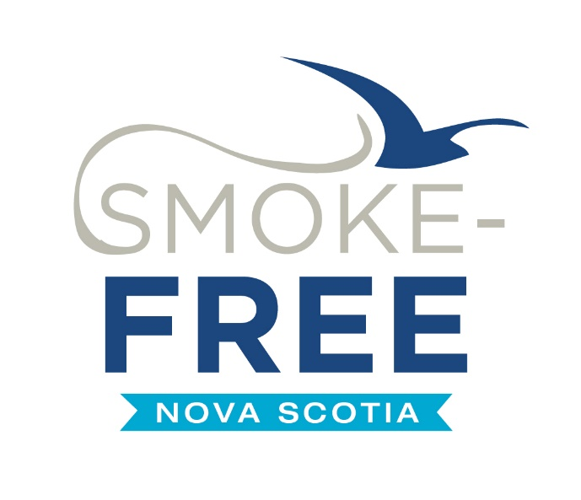 |  | 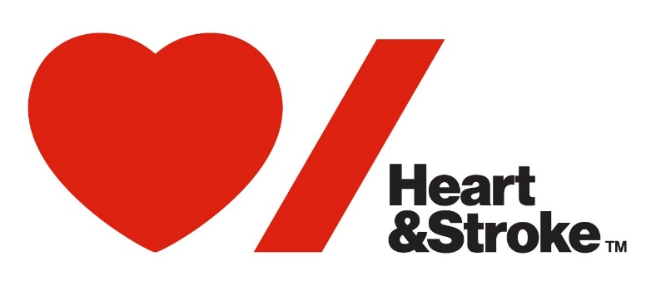  ™The heart and / Icon on its own and the heart and / Icon followed by another icon or words are trademarks of the Heart and Stroke Foundation of Canada used under license.

Tobacco as a crucial health issue
The Canadian Cancer Society places a high priority on tobacco control given its direct relationship with cancer. Tobacco causes about 30% of cancer deaths, and approximately 85% of lung cancer deaths.

Tobacco is the leading cause of preventable disease and death in Canada. Smoking increases the risk of these type of cancer: nasal cavity, mouth and throat, larynx, esophagus, stomach, lung pancreas, liver, colon and rectum, bladder, kidney, renal pelvis and ureter, ovarian, cervix, neuroendocrine and acute myelogenous leukemia.
It is estimated that smoking costs the Canadian health care system $16.2 billion in health care and indirect economic costs annually, including $6.5 billion in direct health care costs.
Increasing the tobacco age to 21 in Nova Scotia and other provinces is inevitable. The sooner the measure is adopted, the sooner there will be reduced youth tobacco use and improved public health.

Health Canada, “Notice of intent — Potential measures to reduce the impact of vaping product advertising on youth and non-users of tobacco products”, Canada Gazette, Part I, February 16, 2019.
Health Canada. (2002). 2000-2002 Report on Tobacco Control - An Update.
Reid JL, Hammond D, Rynard VL, Madill CL, Burkhalter R. Tobacco Use in Canada: Patterns and Trends, 2017 Edition. Waterloo, ON: Propel Centre for Population Health Impact, University of Waterloo.
RJ Reynolds, “Estimated Change in Industry Trend Following Federal Excise Tax Increase,” September 10, 1982.
. Jason LA, Berk M, Schnopp-Wyatt DL, Talbot B. Effects of enforcement of youth access laws on smoking prevalence. Am J Community Psychol. 1999;27(2):143-160. doi: 10.1023/A:1022831617055
Reid JL, Hammond D, Rynard VL, Madill CL, Burkhalter R. Tobacco Use in Canada: Patterns and Trends, 2017 Edition. Waterloo, ON: Propel Centre for Population Health Impact, University of Waterloo.
Ribisl KM, Norman GJ, Howard-Pitney B, Howard KA. Which adults do underaged youth ask for cigarettes? American Journal of Public Health. 1999;89(10):1561–1564
Morales et al, Cigarette Exposure, Dependence & Craving are Related to Insula Thickness in Young Adult Smokers; Nature/Neuropsychopharmacology, 2014, pages 1-7
Institute of Medicine. Public health implications of raising the minimum age of legal access to tobacco products. Washington, DC: National Academies Press, 2015
Winickoff JP, Hartman L, Chen ML, Gottlieb M, Nabi-Burza E, DiFranza JR. Retail impact of raising tobacco sales age to 21 years. Am J Public Health 2014;104:e18-21
Ipsos, National Smoking Poll, Prepared for Canadian Cancer Society, January 2018.
King BA, Jama OA, Marynak KL, Promoff GR. Attitudes toward raising the minimum age of sale for tobacco amongst US adults. Am J Prev Med 2015; 49:538-8.

